Reading in the STAAR Genre
Handout 7
Before Reading:
- Read the TITLE
- Read all of the TEXT FEATURES
- Determine the GENRE and write it at the top of the page:
Informational | Fiction | Poetry
During Reading:
INFORMATIONAL | FICTION | POETRY
  Text Features    Title It  Main Idea | 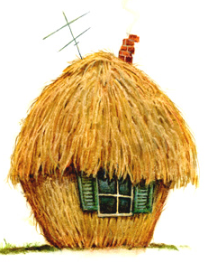  Character(s)  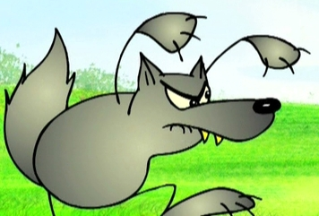  Setting  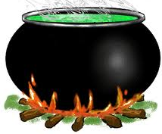  Problem    Solution  Theme |     Read it twice  Listen to the sound of the poem    Visualize images  Consider the Meaning of phrases  Determine the Form  Theme
Office of the Associate Superintendents for Elementary Education

